Homeowners Association (HOA) Meeting

Agenda/Minutes

Meeting: January 16, 2024 – 7:00pm – RHPL Conference Room A
Participants: Joe Porwoll, Gordon Duda, Rich Sickon, Jeff Wagner, Noreen Meganck, Aimee Grahn, Erin Weaver, Sean Donovan, Mike Muccino
Absent: Susan Mason, Jessi Lee, Nancy Troyer, Mike Homant, Nancy Troyer, Scott Ronan
Approve November Minutes
Opening Remarks (Joe Porwoll): Nancy Troyer sent an email on 01/11/2024 with a letter of resignation. Susan Mason & Jessi Lee have not attended any meeting or notified any board member of absence for 3 consecutive meetings. We will vote at the next meeting to remove from the board. Libby Wilson would like to join the board and help Erin with social events. Erin nominated her, board approved. Libby appreciated the acceptance.
Signature of checks on bank accounts was discussed. Currently, only Brian Cain, previous treasurer, is the only authorized member to sign checks. Mike has all checks done electronically, so no need to actually sign a check. Board voted to designate Mike and Joe as only authorized individuals. They will work to update the account.
Treasurer Remarks (Mike Muccino): Mike has spent some time researching CD rates at various banks and credit unions. Credit Unions have better interest rates. The goal is to protect the storm sewer funds by putting in a CD. He will continue to work on this.
Budget: Board discussed setting a budget for 2024. Balance as of 1/1/24 is $54,624.49 with more income coming in June. Dues increase was approved at a previous meeting, so dues will be $191 this year. With current balance and June income, we will have a projected deficit of $2800 with projected expenses. We prioritized expenses to see where we can cut costs.
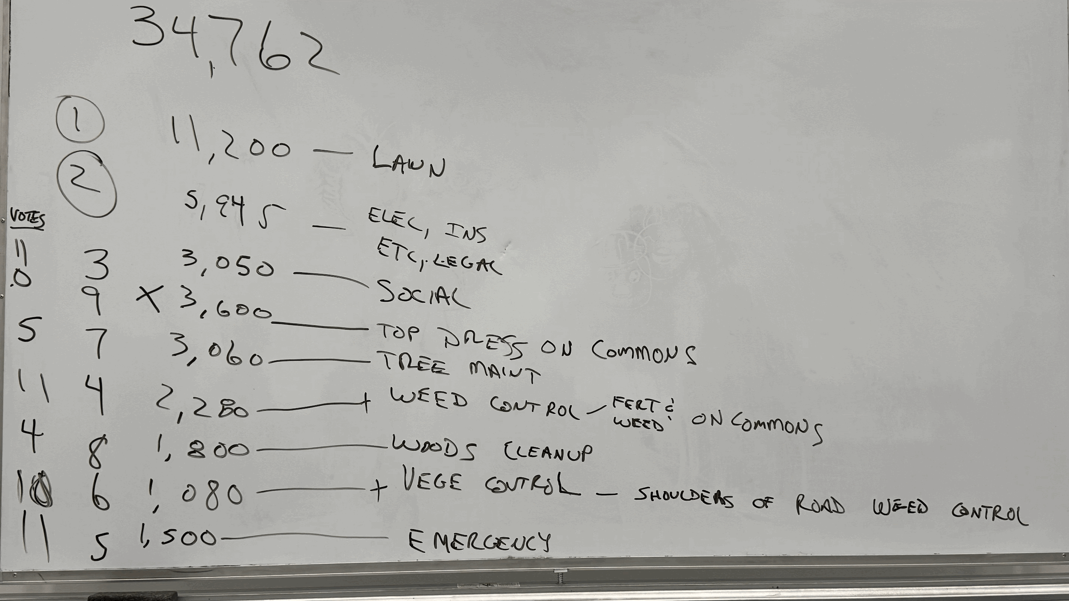
Board voted to not do Top Dressing in the Commons area which will save $3600. Any excess revenue we have at the end of 2024 will go into Storm Sewer escrow.
Deed Restrictions: (Sean Donovan)
Susan is not responding to Sean for committee meetings and information either. Committee sent out an initial email to all members. Gordon & Sean are planning to go door-to-door for those that we don’t have an email address for.
Social Update: (Erin Weaver) Nothing new to add, but has a lot of ideas. Board approved budget of $3050 for social events for 2024. She will work on this and update at the next meeting.
Welcome Committee Update: Since Nancy has resigned, Kathy Wagner has agreed to take this on. Motion was made and board approved.
City Liaison: (Gordon Duda) Nothing new to update.
New Business:
- Walton Oaks Development is moving along. Final plans are expected to be submitted with the city soon. It will then have to go to the planning and zoning commission.
- Aimee discussed the Google One account. It is due to be renewed on the 22nd of each month. She would like to get it off her credit card and paid by the HOA directly. Mike said he would take care of it.
- Sandwich board signs were taken over by Libby. Aimee dropped off supplies and keys.
Next Meeting is scheduled for 3/7 @ 7pm at City Hall. Check facebook or our website for meeting information.

